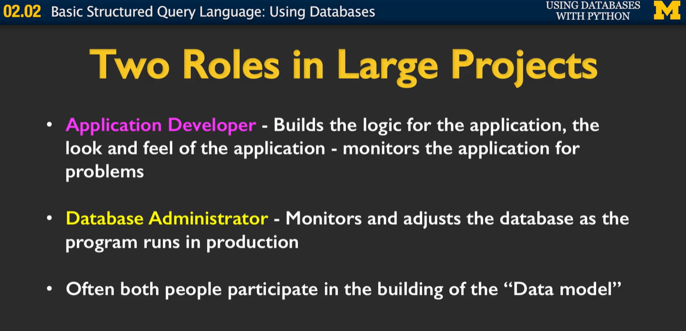

MySql – open source - MARDB – for websites

Oracle – enterprise

Postgres – oracle衍生品fast

SQLite – built part of the software

